This section is about to create a muştconainer app with kubernetes. İt also describes kubernetes volume, persistent volüme, persistence volüme claim . Also define environment variables needed for postgres and redis.

Delete previosu kubernetes deployment objects.

$ kubectl get deployments

$ kubectl get services

$ kubectl delete deployment client-deployment

$ kubectl delete services client-node-port

İf you want to apply all config files in a directoy such as “k8s”

Use

$ kubectl apply –f k8s

#to see a running pod’s logs:

Kubectl logs server-deployment-28548942

VOLUMES:

To see persistence volüme info:

$ kubectl get storageclass

$kubectl describe storageclass

#get persistence volumes created after config files changed.

$kubectl get pv

Use a claim config file to ask for persistence volüme from kubetrnrtes. This file will be attached top od config file

database-persistent-volume-claim.yaml:

apiVersion: v1

kind: PersistentVolumeClaim

metadata:

name: database-persistent-volume-claim

spec:

accessModes:

- ReadWriteOnce

resources:

requests:

storage: 2Gi

postgres-deployment.yaml:

apiVersion: apps/v1

kind: Deployment

metadata:

name: postgres-deployment

spec:

replicas: 1

selector:

matchLabels:

component: postgres

template:

metadata:

labels:

component: postgres

spec:

volumes:

- name: postgres-storage

persistentVolumeClaim:

claimName: database-persistent-volume-claim

containers:

- name: postgres

image: postgres

ports:

- containerPort: 5432

volumeMounts:

- name: postgres-storage

mountPath: /var/lib/postgresql/data

subPath: postgres

CREATING AN ENCODED SECRET for PGPASSWORD:

Run an imperative command to manuaaly create a secret object:

$ kubectl create secret generic pgpassword --from-literal=PGPASSWORD="postgrespassword" $kubectl get secrets

Previous docker architecture:

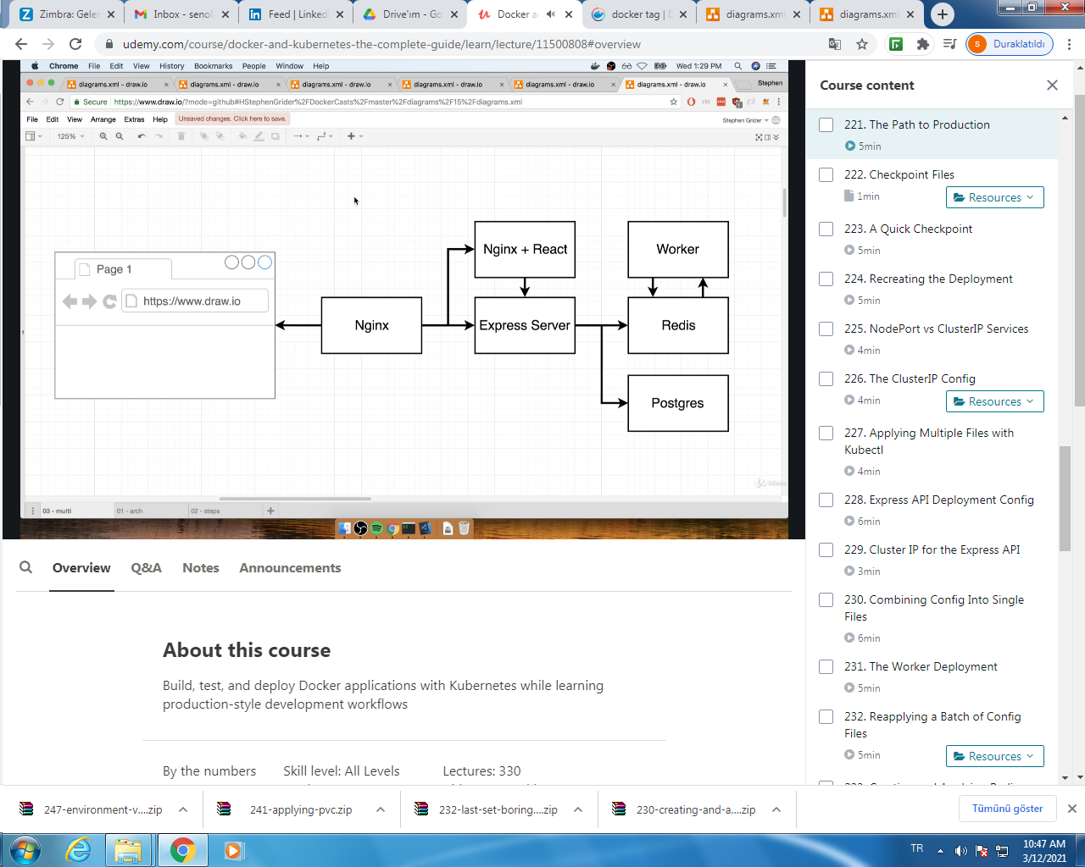

Kubernetes architecture:

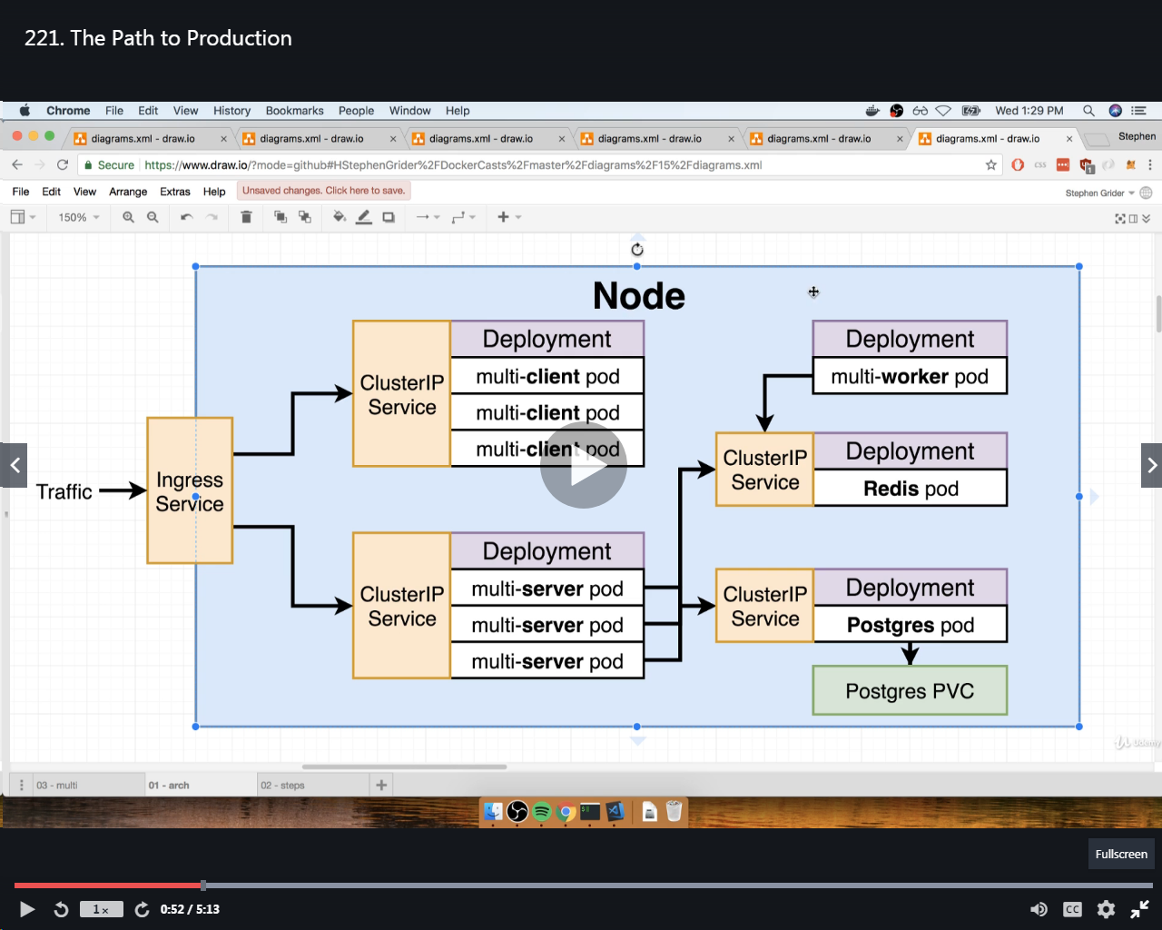

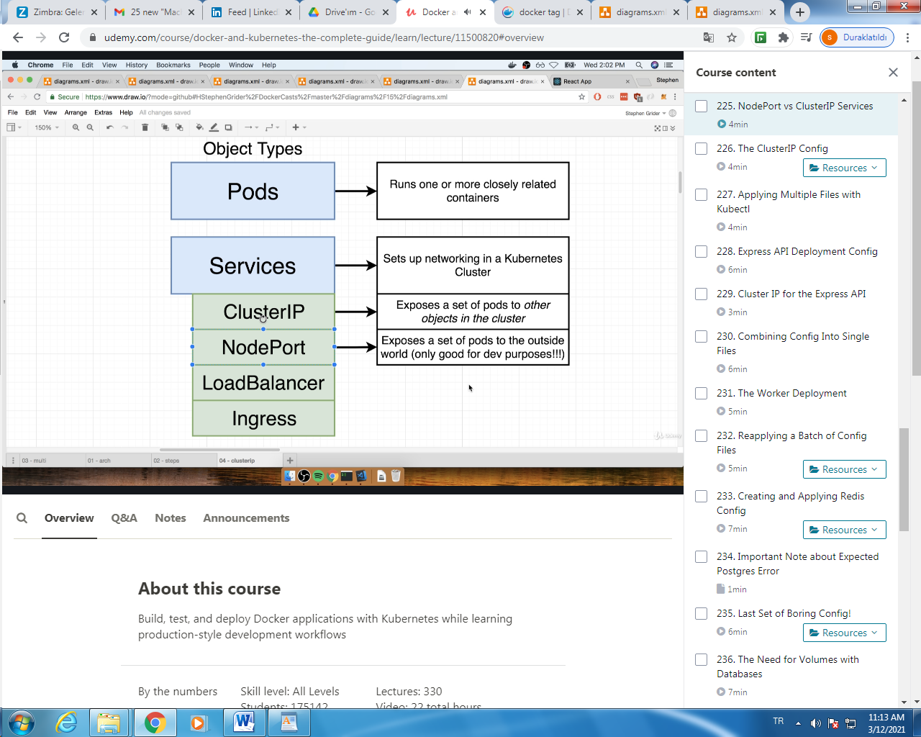

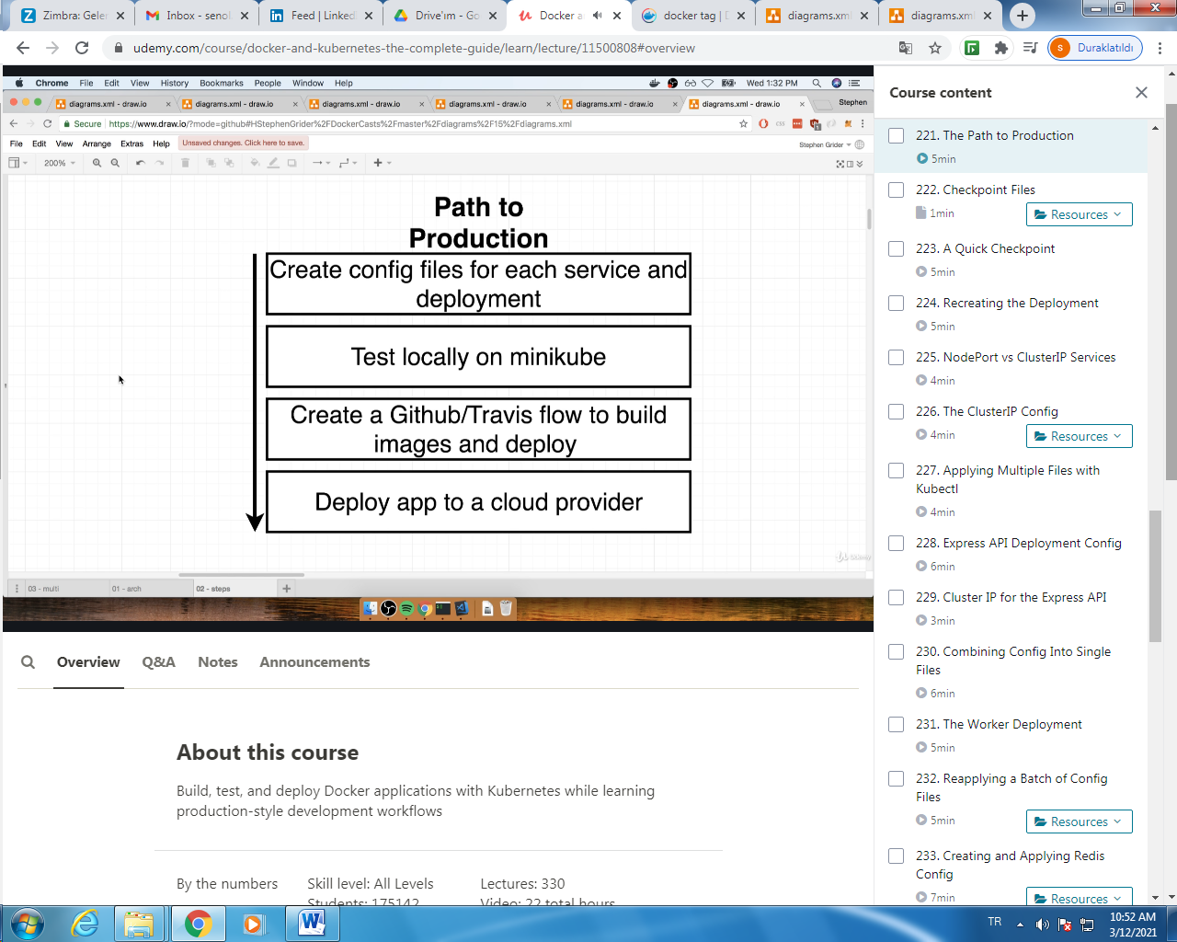

VOLUMES:

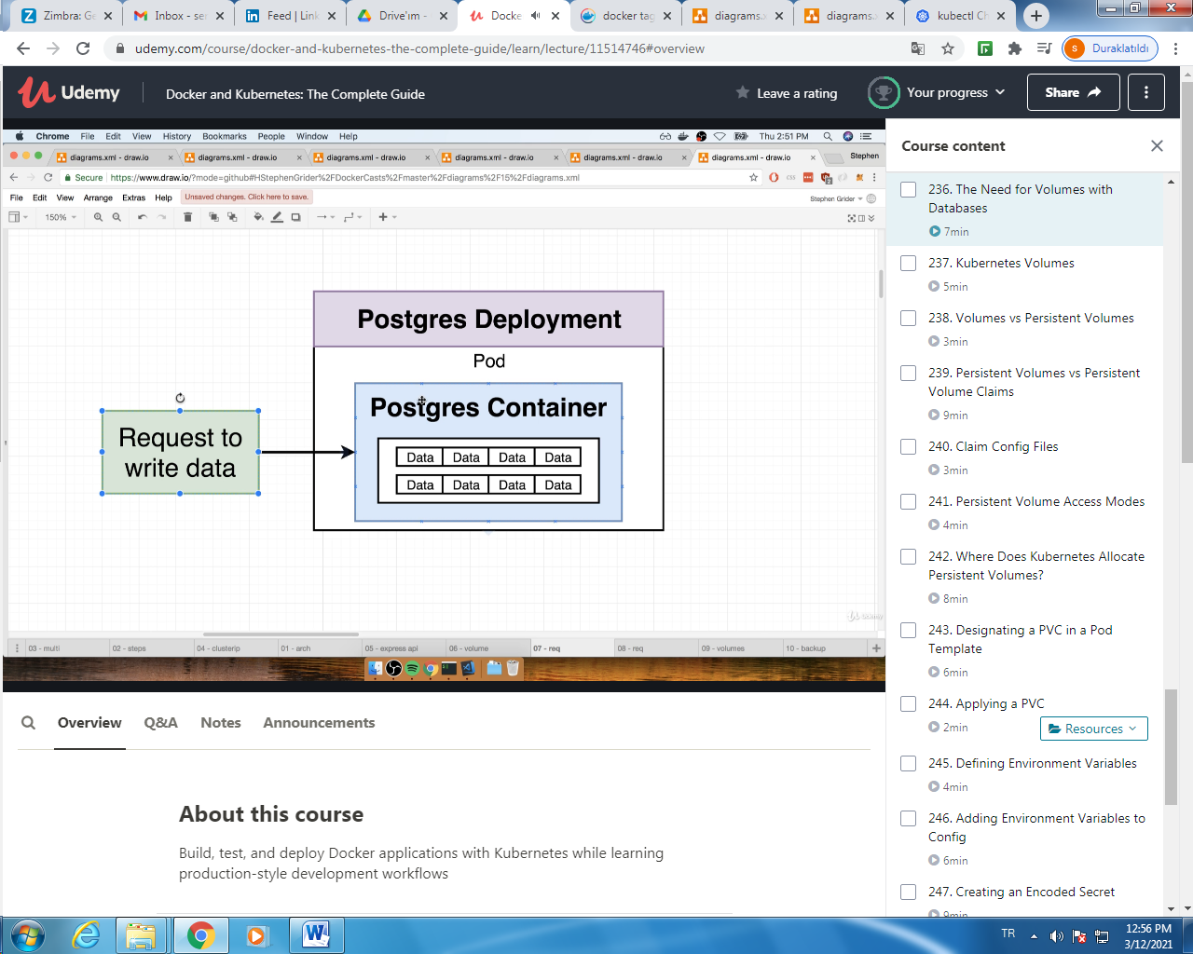

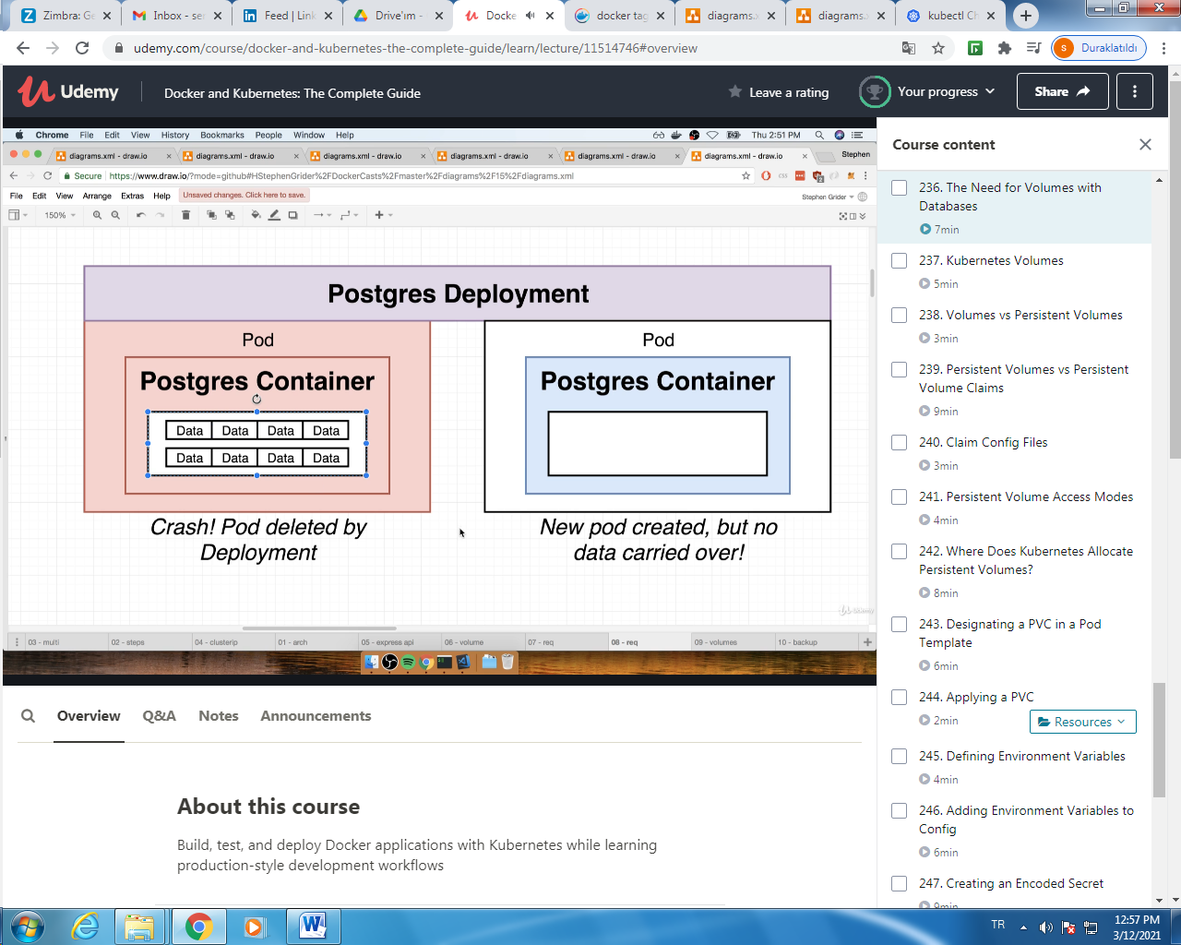

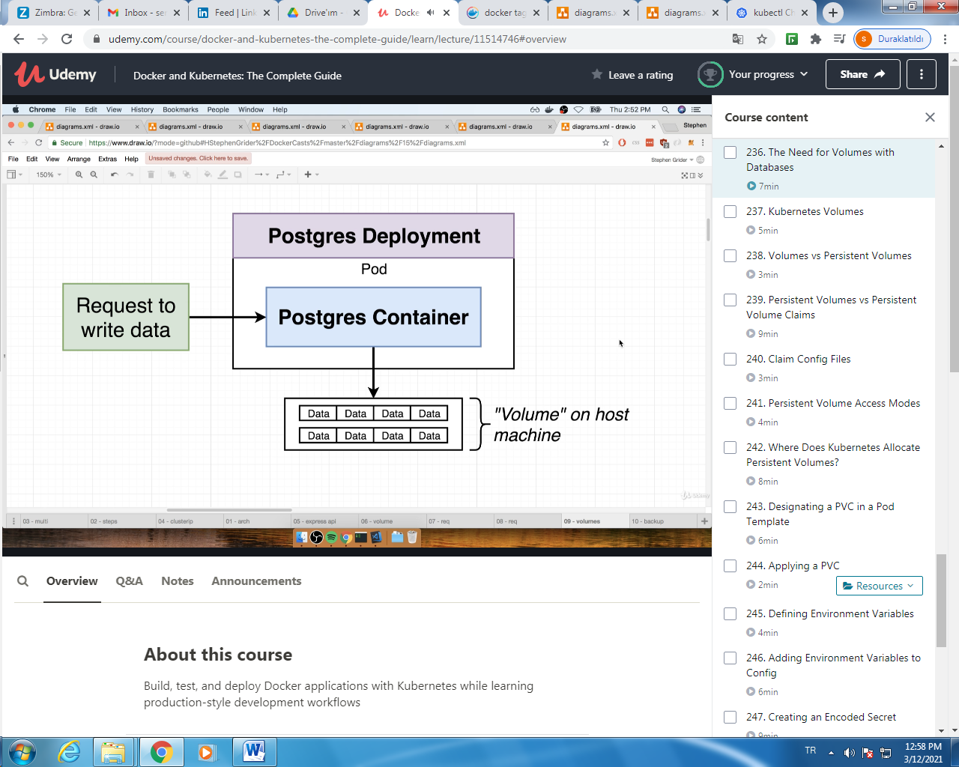

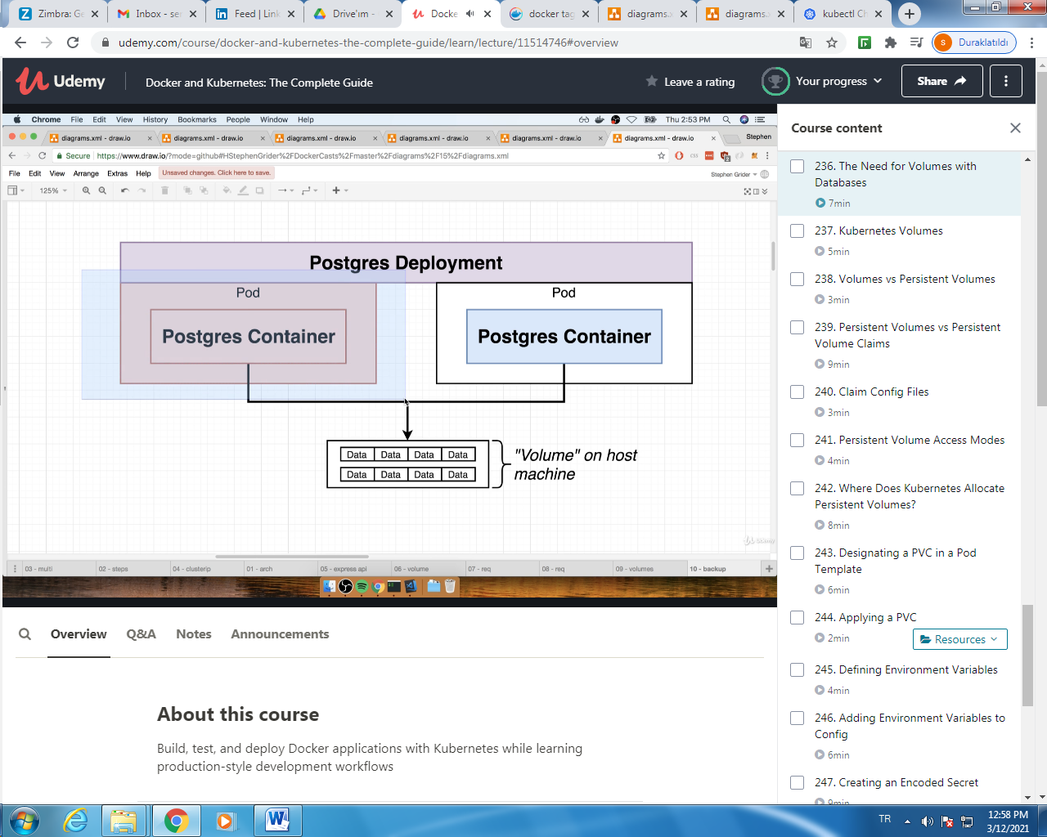

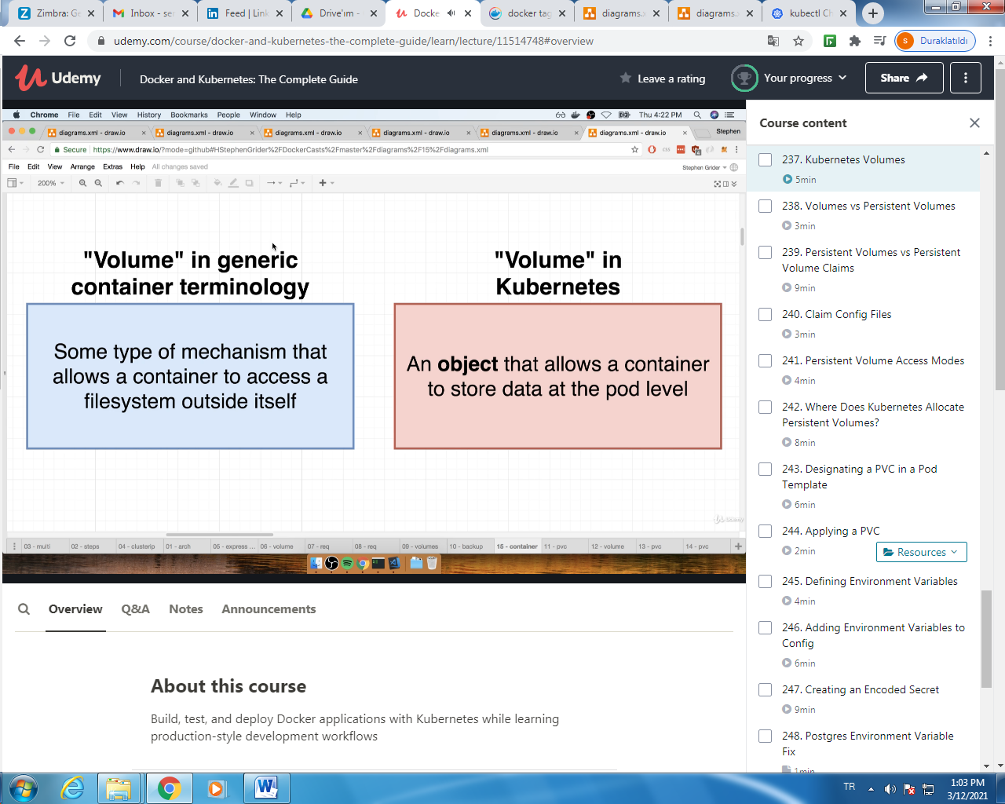

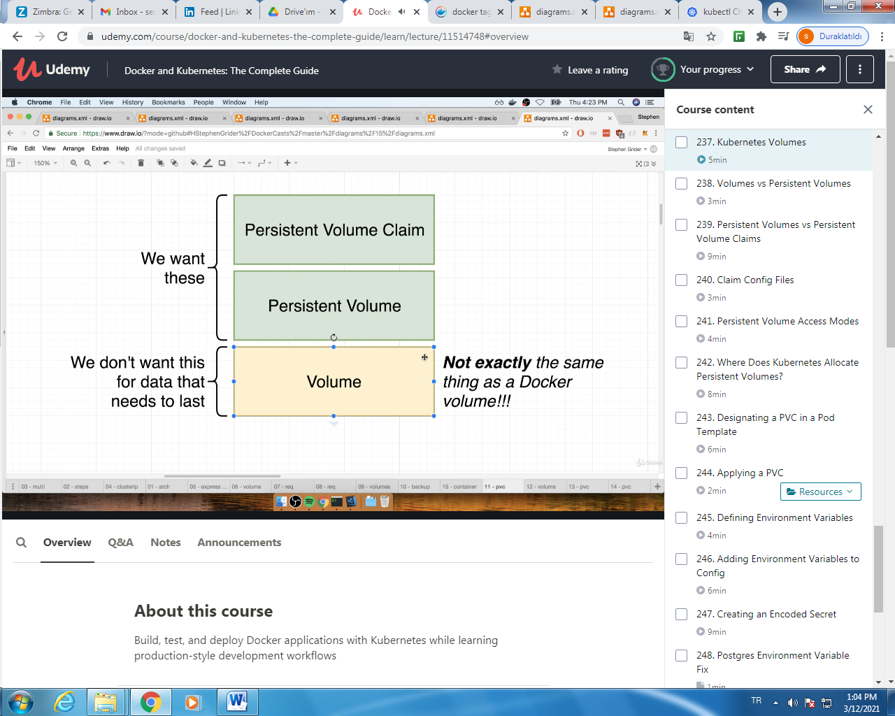

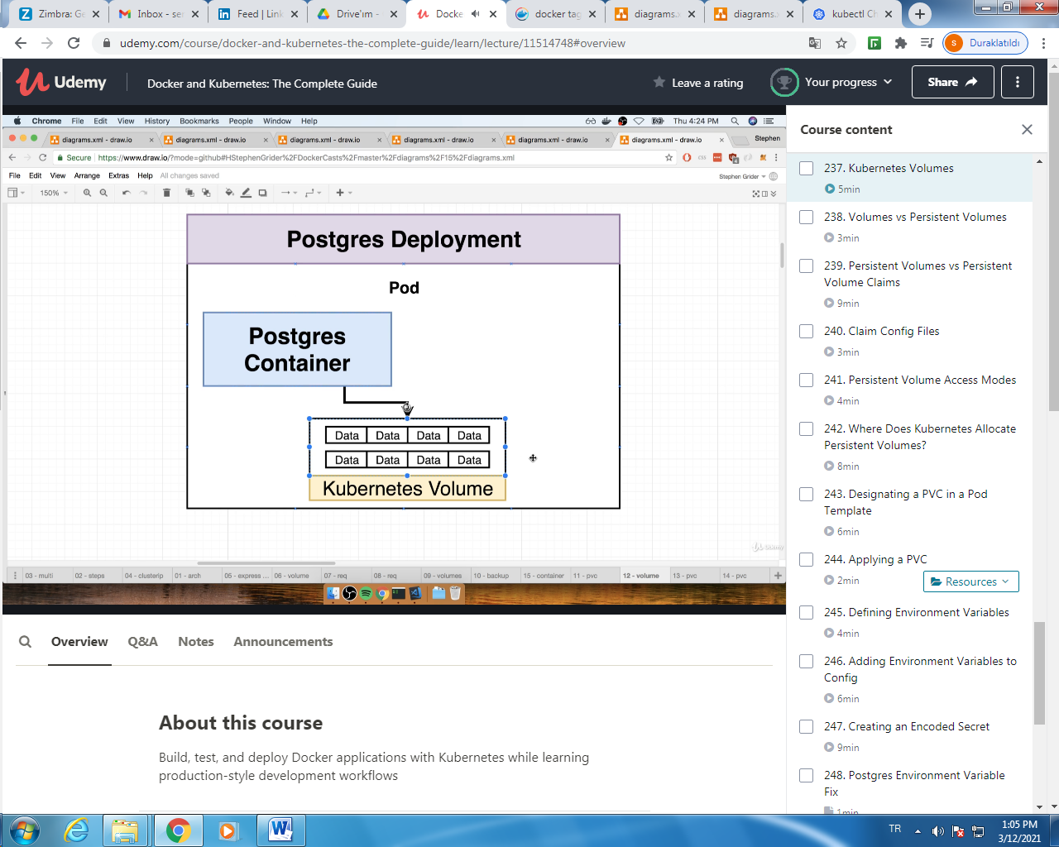

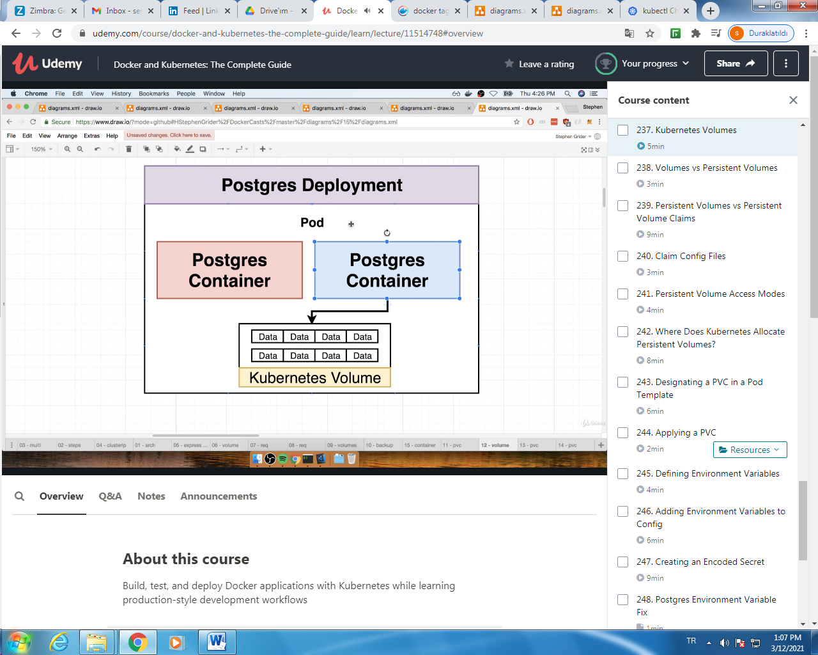

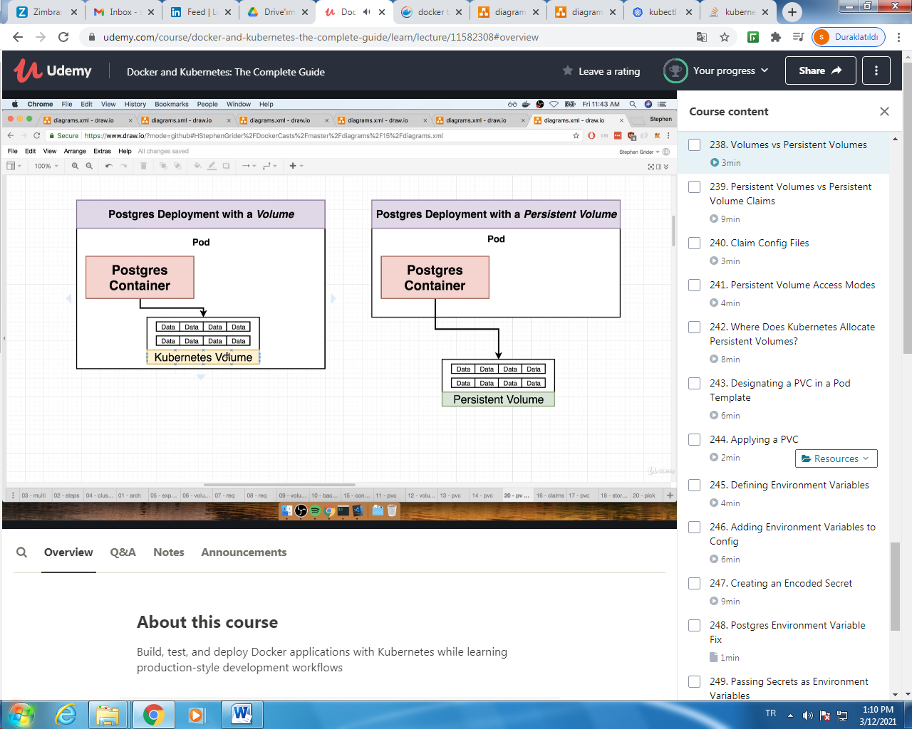

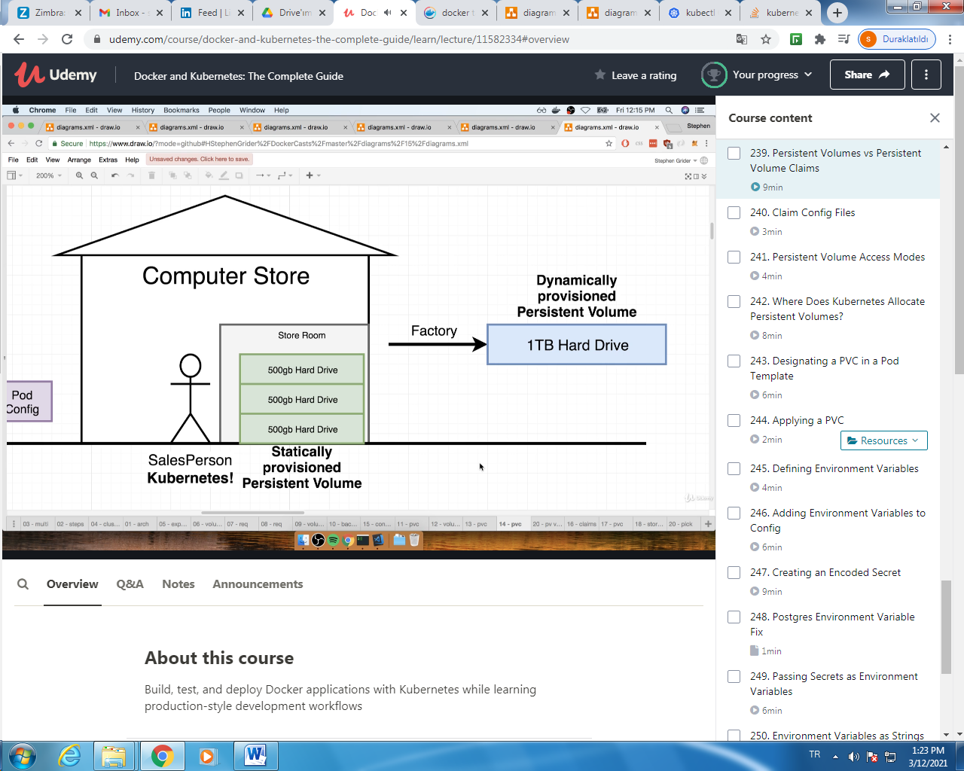

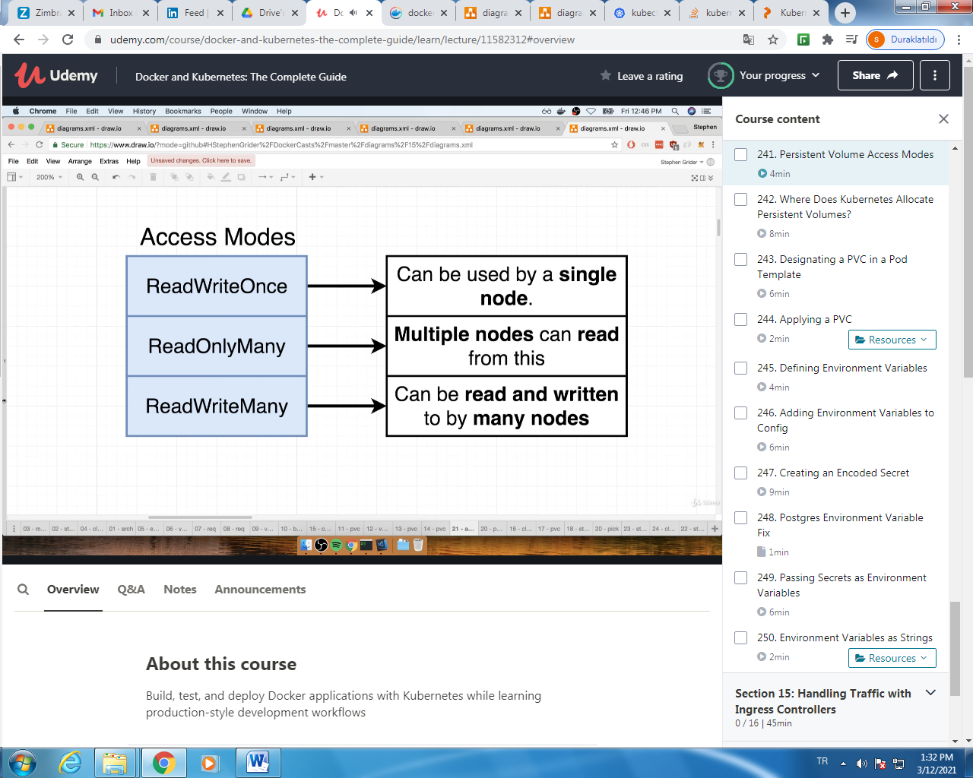

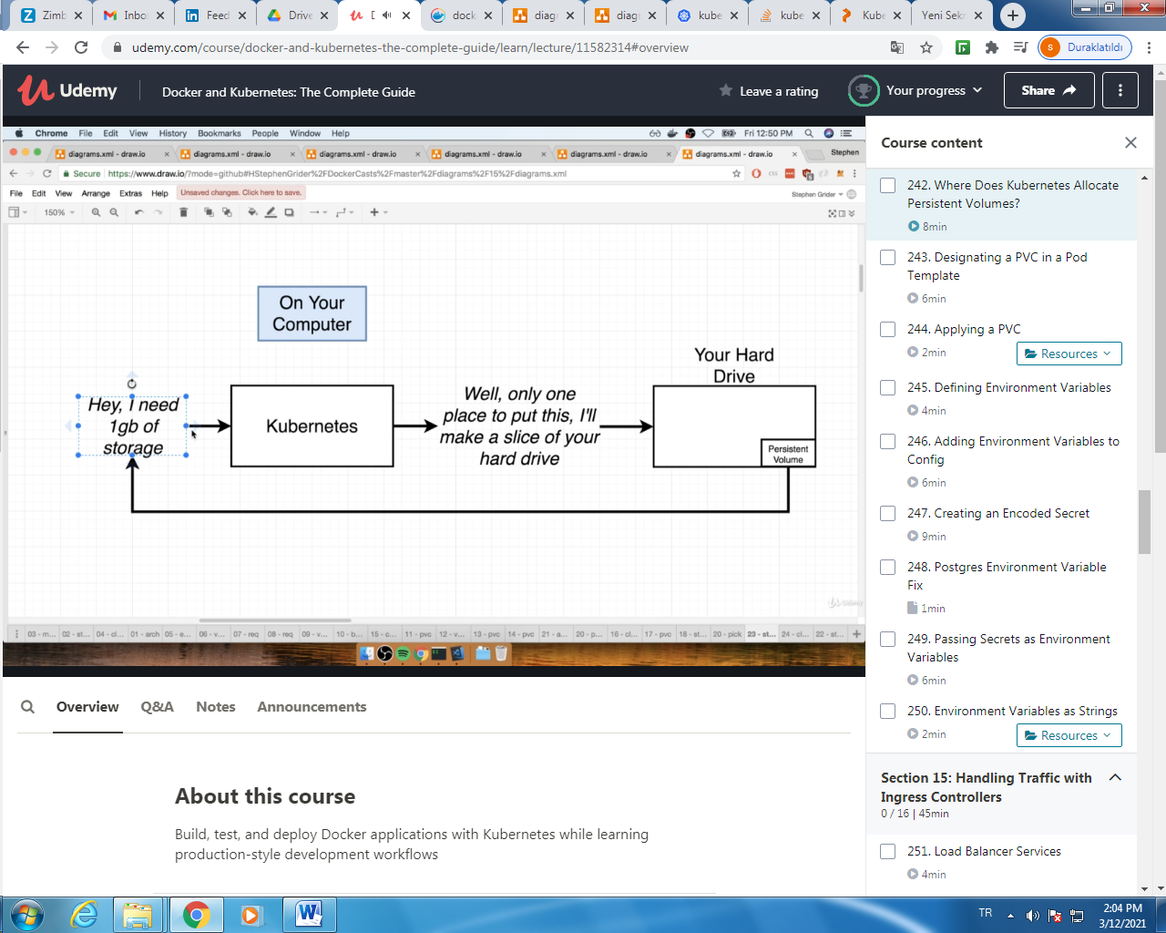

$ kubectl get storageclass

$kubectl describe storageclass

#get persistence volumes created after config files

$kubectl get pv

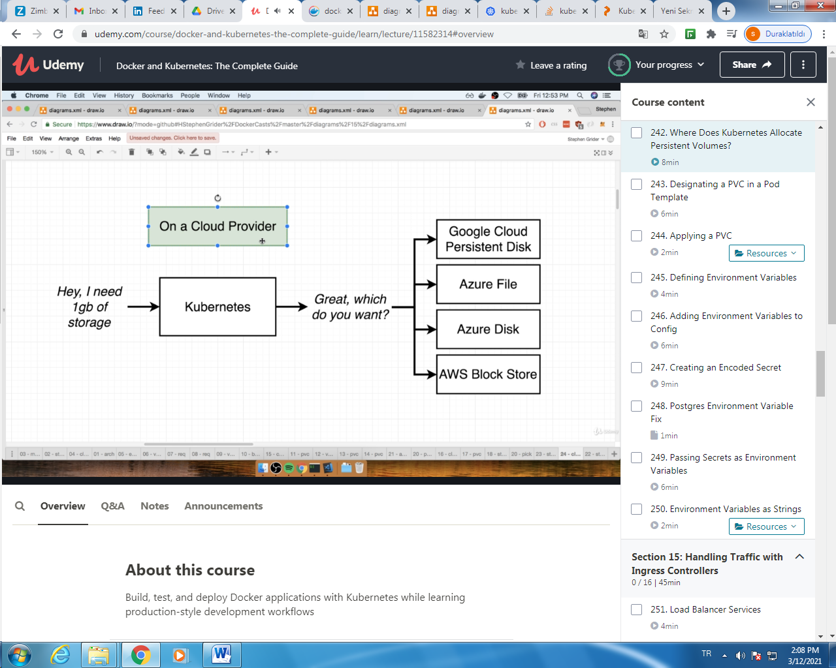

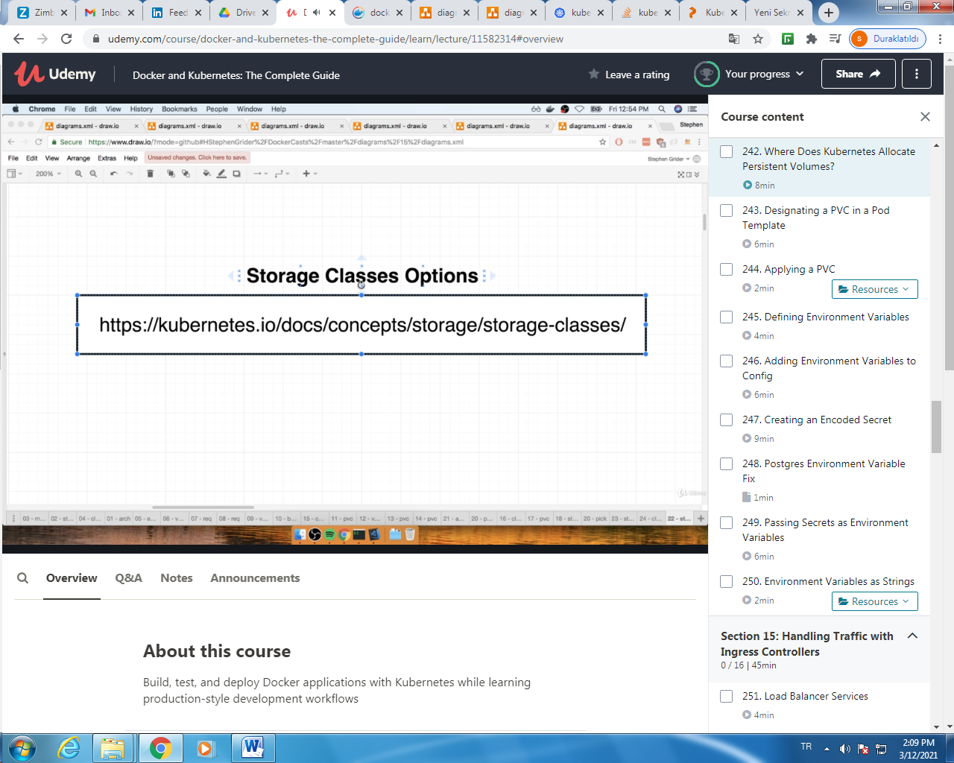

ENVIRINMENT VARIABLES:

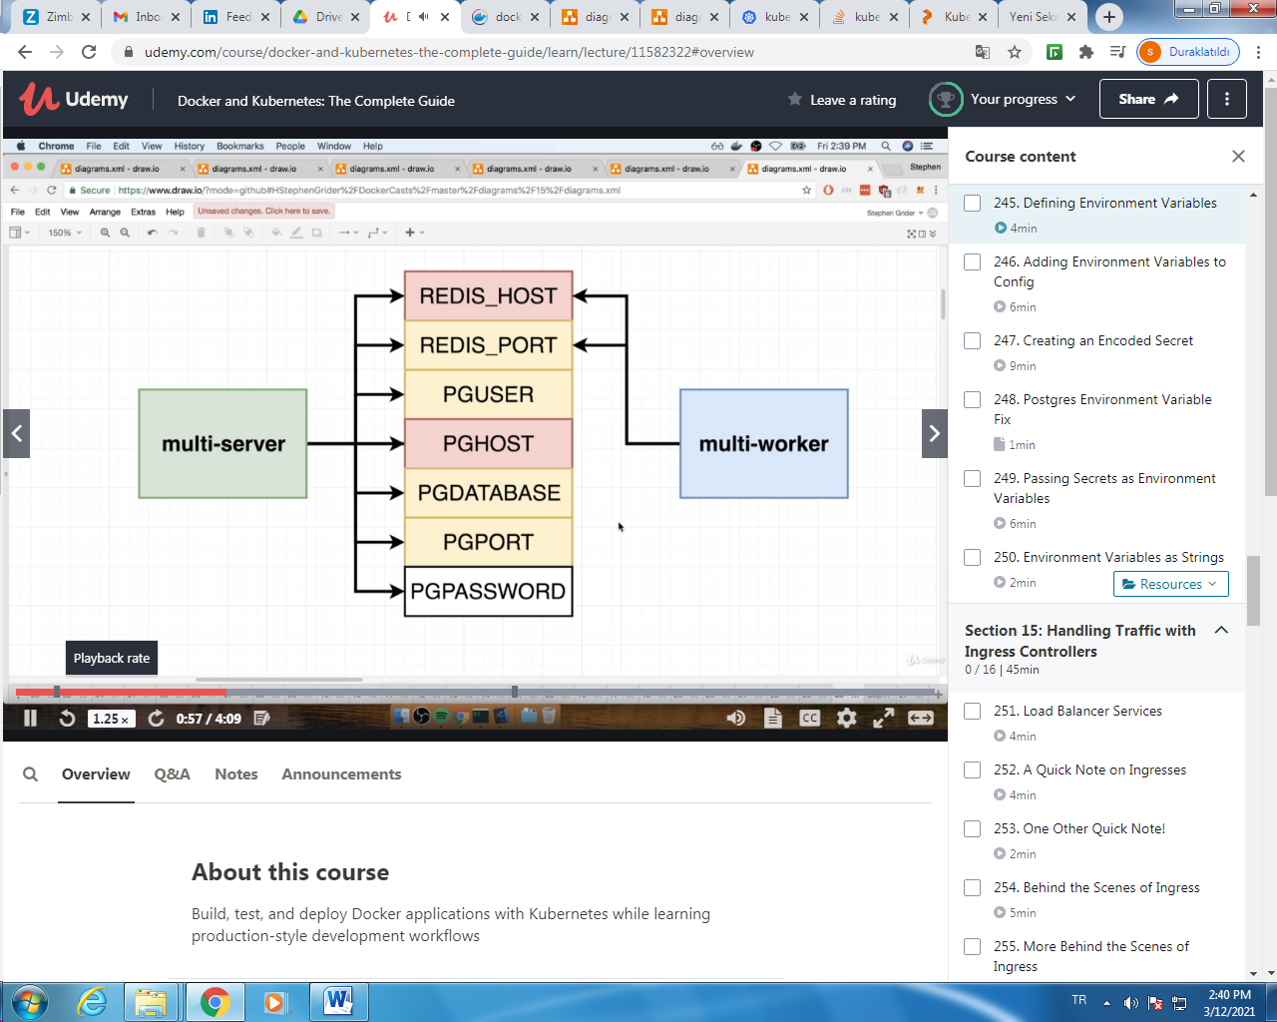

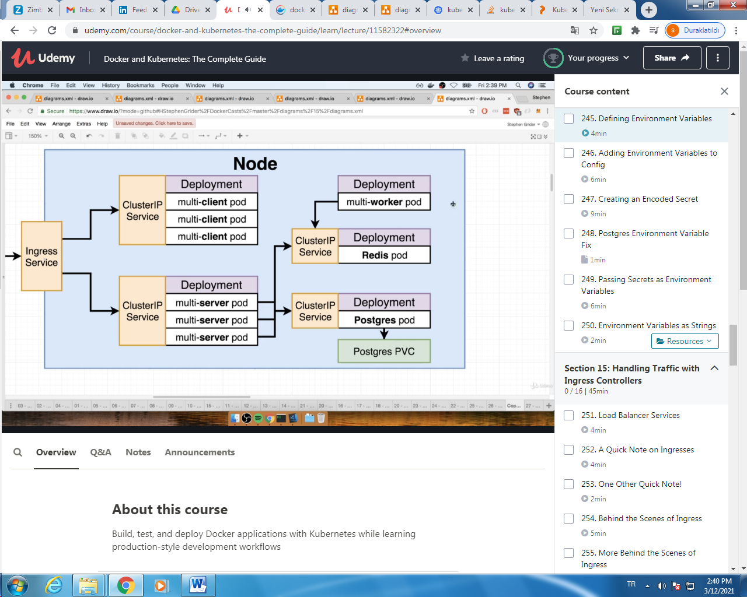

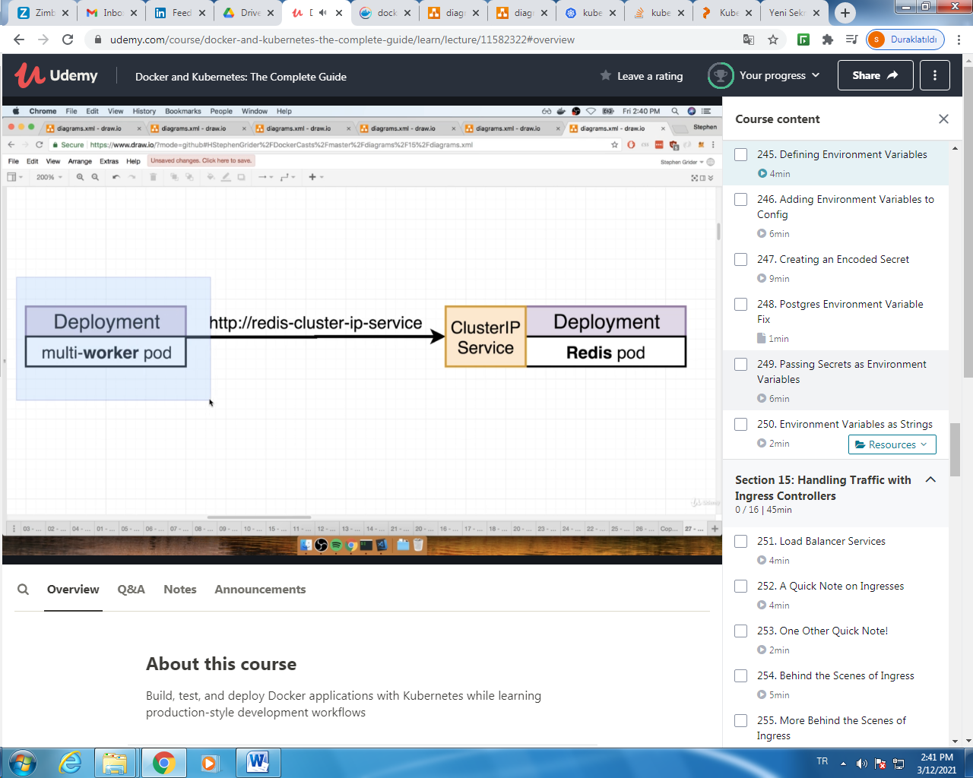

CREATING AN ENCODED SECRET for PGPASSWORD:

Run an imperative command to manuaaly create a secret object:

$ kubectl create secret generic pgpassword --literal PGPASSWORD=905hfeısag

$kubectl get secrets

